**For Immediate Release: March 21, 2024**

**Orion showcases new circular carbon blacks for wire-and-cable, other polymer applications**

**at NPE2024: The Plastics Show**

HOUSTON – [Orion S.A.](https://www.orioncarbons.com/index_en.php)  (NYSE: OEC), a global specialty chemicals company, will showcase two new sustainable specialty carbon black grades suitable for wire-and-cable applications at NPE2024: The Plastics Show. In addition, Orion (booth S34099) will highlight its broad portfolio of conductive additives for pipes, films, injection-molded parts, adhesives and sealants as well as for wire-and-cable applications. NPE2024 takes place May 6-10 in Orlando, Florida.

Produced from end-of-life tire pyrolysis oil, the new circular grades match the performance of regular, fossil-based specialty carbon black. Orion tests show they have the same conductivity properties, high purity level, jetness and tinting strength as regular specialty carbon blacks. Compliant with European and international food contact standards, the new circular blacks are also suitable for piping, film, fiber, packaging and automotive applications.

“Our customers report the new circular blacks are meeting the same performance requirements as regular specialty carbon blacks,” said Kevin Milks, Orion marketing manager for Polymers and Batteries. “We’re eager to understand our customers’ concerns, resolve their challenges with ingenuity and innovation, and develop grades to address their specific performance requirements.”

Also at NPE2024, Orion will present carbon blacks that improve performance by modifying rheology and imparting UV-resistance as well as conductivity characteristics. Marketed under PRINTEX®, AROSPERSE® and other brand names, these grades readily disperse in polymers and show very low levels of ionic contamination.

In wire-and-cable applications, Orion high-performance conductive additives extend service life by imparting desired conductivities, superior surface smoothness and UV protection to medium-voltage distribution and high voltage transmission cables.

Orion follows a sustainability approach based on developing solutions for customers as they adapt to three key mega-trends: the circular economy, electrification and decarbonization.

“Within our sustainability strategy, we are committed to recycling carbon black and producing circular specialty grades with equivalent performance to regular specialty blacks,” said Jennifer Stroh, PhD, Orion director of sales and marketing. “In fact, we have a long history with sustainable grades, beginning with PRINTEX Nature, our first grade produced from renewable oils more than 10 years ago. And, we continue to lead in producing sustainable carbon blacks.”

Orion develops partnerships to provide carbon black for wire-and-cable, injection molding and other polymer applications that support the country’s growing market for electric vehicles.

For more information about Orion’s sustainability performance and initiatives, visit [Orion’s Strategy for Sustainable Solutions](https://orioncarbons.com/sustainability/).

**About Orion S.A.**

Orion S.A. (NYSE: OEC) is a leading global supplier of carbon black, a solid form of carbon produced as powder or pellets. The material is made to customers’ exacting specifications for tires, coatings, ink, batteries, plastics and numerous other specialty, high-performance applications. Carbon black is used to tint, colorize, provide reinforcement, conduct electricity, increase durability and add UV protection. Orion has innovation centers on three continents and 15 plants worldwide, offering the most diverse variety of production processes in the industry. The company’s corporate lineage goes back more than 160 years to Germany, where it operates the world’s longest-running carbon black plant. Orion is a leading innovator, applying a deep understanding of customers’ needs to deliver sustainable solutions. For more information, please visit [orioncarbons.com](https://www.orioncarbons.com/index_en.php).

**Forward-Looking Statements**

This document contains certain forward-looking statements within the meaning of the U.S. Private Securities Litigation Reform Act of 1995. Forward-looking statements are statements of future expectations that are based on current expectations and assumptions and involve known and unknown risks and uncertainties that could cause actual results, performance or events to differ materially from those expressed or implied in these statements. You should not place undue reliance on forward-looking statements. Each forward-looking statement speaks only as of the date of the particular statement. New risk factors and uncertainties emerge from time to time and it is not possible to predict all risk factors and uncertainties, nor can we assess the extent to which any factor, or combination of factors, may cause actual results to differ materially from those contained in any forward-looking statements. We undertake no obligation to publicly update or revise any forward-looking statement as a result of new information, future events or other information, other than as required by applicable law.

Contact:

William Foreman

Director of Corporate Communications and Government Affairs

Orion S.A.

Mobile: +1 281-889-7833

[william.foreman@orioncarbons.com](mailto:william.foreman@orioncarbons.com)

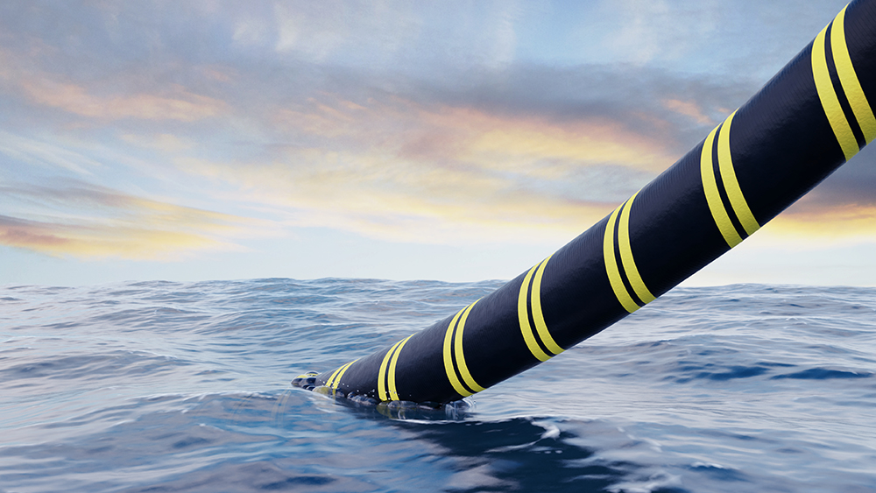

Caption:

Orion conductive additives boost polymer performance in wire-and-cable, injection molding and other applications.

###