**FOR IMMEDIATE RELEASE: Sept. 14, 2023**

**Orion showcases new circular carbon black for polymer applications**

**at 2023 Compounding World Expo North America**

HOUSTON – At the 2023 Compounding World Expo North America, global specialty chemicals company [Orion S.A.](https://www.orioncarbons.com/index_en.php)  (NYSE: OEC) will present its first circular specialty carbon black for polymer applications. In addition, Orion (booth 411) will highlight its broad portfolio of conductive additives for wire-and-cable applications, injection-molded parts, adhesives and sealants, films and piping. The 2023 Compounding World Expo North America takes place from Nov. 15 – 16 in Cleveland, Ohio.

Produced from end-of-life tire pyrolysis oil, the new circular grade matches the performance of regular, fossil-based specialty carbon black. Orion tests show it has the same dispersibility, high purity level, jetness and tinting strength as regular specialty carbon blacks. Compliant with European and international food contact standards, the new circular black is suitable for piping, film, fiber, packaging and automotive applications.

“Current customers confirm that the new circular black is performing as well as regular specialty carbon blacks,” said Kevin Milks, Orion marketing manager, Polymers and Batteries. “We’re looking to partner with our customers to understand their needs and develop grades to meet their specific performance requirements.”

Also at the Expo, Orion will present carbon blacks that improve performance by modifying rheology and imparting UV-resistance as well as conductivity characteristics. Marketed under PRINTEX®, AROSPERSE® and other brand names, these grades disperse readily in polymers and show very low levels of ionic contamination.

Orion follows a sustainability approach based on developing solutions for customers as they adapt to three key mega-trends: the circular economy, electrification and decarbonization.

“Orion is invested in and committed to recycling carbon black and successfully producing specialty circular grades without compromising performance,” said Jennifer Stroh, Orion director of sales and marketing.

Emphasizing Orion’s competitive advantage, she noted the company produced its first grade from renewable oils, PRINTEX Nature, more than 10 years ago and continues to lead in producing sustainable carbon blacks.

Milks added Orion is actively undertaking partnerships to provide carbon black for wire-and-cable, injection molding and other polymer applications that support the country’s growing market for electric vehicles.

For more information about Orion’s sustainability performance and initiatives, visit the [Orion Sustainability Roadmap](https://investor.orioncarbons.com/sustainability/Sustainability-Roadmap/default.aspx).

**About Orion S.A.**

Orion S.A. (NYSE: OEC) is a leading global supplier of carbon black, a solid form of carbon produced as powder or pellets. The material is made to customers’ exacting specifications for tires, coatings, ink, batteries, plastics and numerous other specialty, high-performance applications. Carbon black is used to tint, colorize, provide reinforcement, conduct electricity, increase durability and add UV protection. Orion has innovation centers on three continents and 15 plants worldwide, offering the most diverse variety of production processes in the industry. The company’s corporate lineage goes back more than 160 years to Germany, where it operates the world’s longest-running carbon black plant. Orion is a leading innovator, applying a deep understanding of customers’ needs to deliver sustainable solutions. For more information, please visit [orioncarbons.com](https://www.orioncarbons.com/index_en.php).

**Forward-Looking Statements**

This document contains certain forward-looking statements within the meaning of the U.S. Private Securities Litigation Reform Act of 1995. Forward-looking statements are statements of future expectations that are based on current expectations and assumptions and involve known and unknown risks and uncertainties that could cause actual results, performance or events to differ materially from those expressed or implied in these statements. You should not place undue reliance on forward-looking statements. Each forward-looking statement speaks only as of the date of the particular statement. New risk factors and uncertainties emerge from time to time and it is not possible to predict all risk factors and uncertainties, nor can we assess the extent to which any factor, or combination of factors, may cause actual results to differ materially from those contained in any forward-looking statements. We undertake no obligation to publicly update or revise any forward-looking statement as a result of new information, future events or other information, other than as required by applicable law.

Contact:

William Foreman

Director of Corporate Communications and Government Affairs

Orion S.A.

Mobile: +1 281-889-7833

[william.foreman@orioncarbons.com](mailto:william.foreman@orioncarbons.com)

Caption:

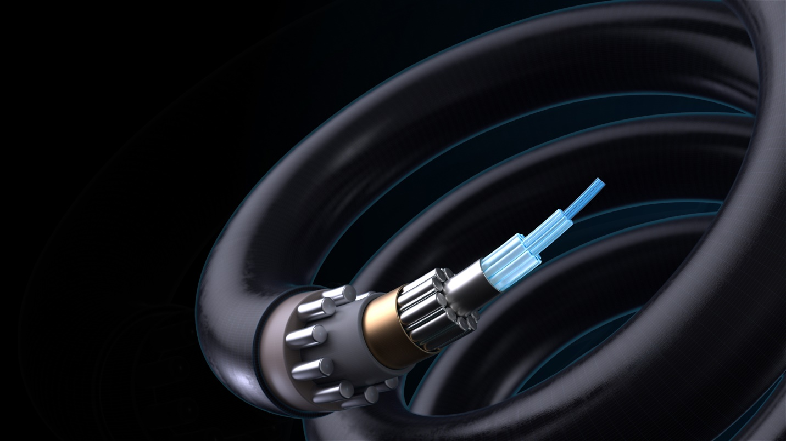

Orion conductive additives boost polymer performance in wire-and-cable, injection molding and other applications.

###