**FOR IMMEDIATE RELEASE: May 3, 2023**

**Orion showcases first circular carbon blacks for coatings at Eastern Coatings Show 2023**

HOUSTON – At the Eastern Coatings Show 2023, global specialty chemicals company [Orion Engineered Carbons](https://www.orioncarbons.com/index_en.php) (NYSE: OEC) will showcase its achievements in sustainability, presenting three new circular grades – one for high jetness and two for tinting applications.

Orion (booth 322) will also launch PRINTEX® kappa 50 conductive carbon black at the show on May 16-18, 2023, in Atlantic City, N. J.

“As a market leader, we continually drive innovations in carbon black, demonstrate our commitment to the coatings industry and deliver added value to our customers,” said Carlos Hernandez, marketing manager, coatings & printing systems for the Americas at Orion. “Following our sustainability strategy, we help our customers participate in the circular economy through our bio-based and circular carbon black grades.”

**First circular carbon blacks**

Designed for high-jetness applications, Orion’s first circular gas black for coatings systems, XPB 10045, is based on pyrolysis oil to support the transition to a circular economy. Broadly compatible with all suitable coatings systems, it helps formulators create more sustainable coatings with comparable application properties to regular specialty carbon blacks.

For tinting applications, Orion’s first circular furnace blacks, XPB 10042 powder and XPB 10049 powder, are also based on pyrolysis oil and offer the same advantages as the high-jetness black. Application properties meet the same high requirements of currently used specialty carbon blacks.

**Launching a new grade**

Introduced in 2013 and previously designated XPB 545, PRINTEX kappa 50 meets or exceeds performance requirements for conductivity, dispersibility and cleanliness at lower concentrations than conventional conductive carbon blacks. It achieves the percolation threshold with low carbon black loading and good coloristic properties.

Orion also will promote its *“Carbon Black Guide.”* Featuring 34 of Orion’s most popular carbon blacks used globally for coatings, the *“Carbon Black Guide”* gives paint formulators a visual sense of the shades they can achieve with different grades. Color chips in the guide show the shades each grade imparts in three coatings types – solid, white blend and alkyd enamel – and details relevant coloristic properties.

For more information about Orion specialty carbon blacks for coatings, contact Carlos Hernandez, marketing manager, coatings & printing systems Americas at [carlos.hernandez@orioncarb](mailto:carlos.hernandez@orioncarb)ons.com.

To learn more about Orion’s sustainability performance and initiatives, visit [Orion Engineered Carbons - Sustainability - Sustainability Roadmap (orioncarbons.com)](https://investor.orioncarbons.com/sustainability/Sustainability-Roadmap/default.aspx).

**About Orion Engineered Carbons**

Orion Engineered Carbons (NYSE: OEC) is a leading global supplier of carbon black, a solid form of carbon produced as powder or pellets. The material is made to customers’ exacting specifications for tires, coatings, ink, batteries, plastics and numerous other specialty, high-performance applications. Carbon black is used to tint, colorize, provide reinforcement, conduct electricity, increase durability and add UV protection. Orion has innovation centers on three continents and 14 plants worldwide, offering the most diverse variety of production processes in the industry. The company’s corporate lineage goes back more than 160 years to Germany, where it operates the world’s longest-running carbon black plant. Orion is a leading innovator, applying a deep understanding of customers’ needs to deliver sustainable solutions. For more information, please visit [orioncarbons.com](https://www.orioncarbons.com/index_en.php).

**Forward-Looking Statements**

This document contains certain forward-looking statements within the meaning of the U.S. Private Securities Litigation Reform Act of 1995. Forward-looking statements are statements of future expectations that are based on current expectations and assumptions and involve known and unknown risks and uncertainties that could cause actual results, performance or events to differ materially from those expressed or implied in these statements. You should not place undue reliance on forward-looking statements. Each forward-looking statement speaks only as of the date of the particular statement. New risk factors and uncertainties emerge from time to time and it is not possible to predict all risk factors and uncertainties, nor can we assess the extent to which any factor, or combination of factors, may cause actual results to differ materially from those contained in any forward-looking statements. We undertake no obligation to publicly update or revise any forward-looking statement as a result of new information, future events or other information, other than as required by applicable law.

Contact:

William Foreman

Director of Corporate Communications and Government Affairs

Government Affairs

Orion Engineered Carbons

Direct: +1 832-445-3305

Mobile: +1 281-889-7833

[william.foreman@orioncarbons.com](mailto:william.foreman@orioncarbons.com)

###

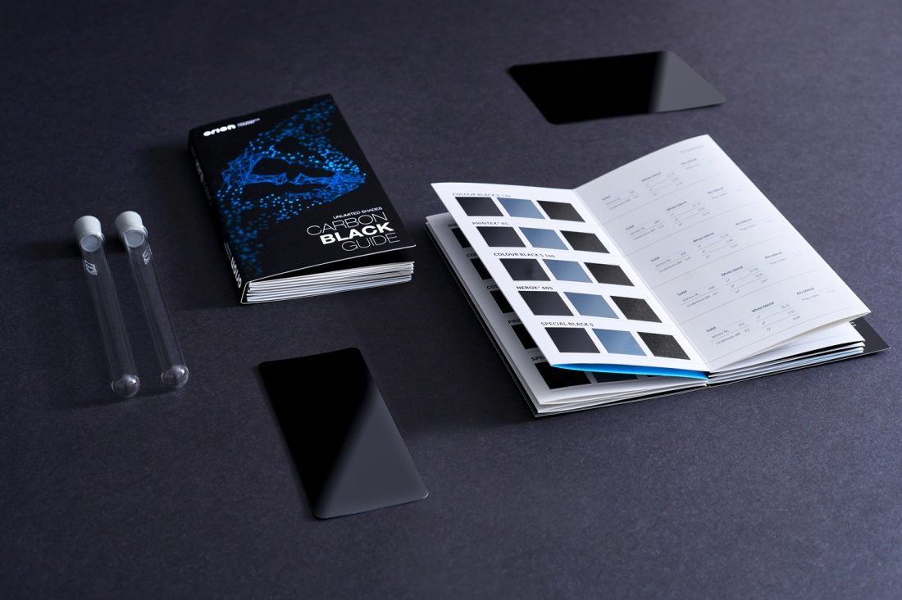

Featuring 34 of Orion’s most popular carbon blacks used globally for coatings, the *“Carbon Black Guide”* gives paint formulators a visual sense of the shades they can achieve with different grades.