**FOR IMMEDIATE RELEASE: April 12, 2023**

**Orion Showcases Specialty Carbon Blacks that Increase Dynamic Charge Acceptance at 2023 BCI Convention and Power Mart Expo**

HOUSTON – At the 2023 BCI Convention and Power Mart Expo, global specialty chemicals company [Orion Engineered Carbons](https://www.orioncarbons.com/index_en.php) (NYSE: OEC) is showcasing PRINTEX® kappa carbon blacks that increase dynamic charge acceptance of advanced lead-acid batteries. Orion (Booth 304) also is highlighting the benefits of its upcoming acetylene-based conductive additives plant. The BCI (Battery Council International) and Power Mart Expo takes place April 24 through April 26, 2023, in Louisville, Ky.

PRINTEX kappa 210, PRINTEX kappa 220 and PRINTEX kappa 240 conductive additives increase the dynamic charge acceptance (DCA) of advanced lead-acid batteries by up to 60% while maintaining acceptable water loss. The very low level of metallic impurities extends battery cycle life. Plus, the modified surfaces maintain conductivity and surface area while suppressing the hydrogen evolution reaction, lowering water loss to acceptable levels. As a result, battery manufacturers can use higher loading to achieve higher charge acceptance.

“The PRINTEX kappa grades give battery manufacturers the most flexibility to formulate and adjust properties, such as charge acceptance, while maintaining acceptable water loss,” said Kevin Milks, marketing manager for polymers and batteries Americas. “They have excellent dispersion and processing properties, which improve handling, process formulation and performance.” Orion carbon black grades also lead the way in purity, economics and reliability.

**One of a Kind**

Orion announced last year it is planning to build the only plant in the U.S. producing acetylene-based conductive additives – critical for lithium-ion batteries, high-voltage cables and other products powering the global transition to electrification and renewable energy.

“Demand continues to grow for lithium-ion batteries for electric vehicles,” said Jennifer S. Stroh, Ph.D., director of specialties sales and marketing Americas. “Our new plant will help serve the expanding market and will offer North American battery manufacturers domestic availability and consistent supply.”

**Improving Conductivity in Lithium-ion Batteries**

For lithium-ion batteries, Orion offers the acetylene-based PRINTEX kappa 100, which has conductive functionalities that improve lithium-ion battery performance. The conductive additive’s exceptional purity and high electrical and thermal conductivity lead to significantly higher power densities and longer battery life than with other carbon blacks. It has a remarkably low carbon footprint and contributes to the reduction of greenhouse gas emissions.

For more information about Orion’s broad portfolio of specialty carbon blacks for battery applications, contact Kevin Milks, marketing manager, polymers and batteries at [kevin.milks@orioncarbons.com](mailto:kevin.milks@orioncarbons.com). To learn more about Orion’s sustainability performance and initiatives, visit [Orion Engineered Carbons - Sustainability - Sustainability Roadmap (orioncarbons.com)](https://investor.orioncarbons.com/sustainability/Sustainability-Roadmap/default.aspx).

**About Orion Engineered Carbons**

Orion Engineered Carbons (NYSE: OEC) is a leading global supplier of carbon black, a solid form of carbon produced as powder or pellets. The material is made to customers’ exacting specifications for tires, coatings, ink, batteries, plastics and numerous other specialty, high-performance applications. Carbon black is used to tint, colorize, provide reinforcement, conduct electricity, increase durability, and add UV protection. Orion has innovation centers on three continents and 14 plants worldwide, offering the most diverse variety of production processes in the industry. The company’s corporate lineage goes back more than 160 years to Germany, where it operates the world’s longest-running carbon black plant. Orion is a leading innovator, applying a deep understanding of customers’ needs to deliver sustainable solutions. For more information, please visit [orioncarbons.com](https://www.orioncarbons.com/index_en.php).

**Forward-Looking Statements**

This document contains certain forward-looking statements within the meaning of the U.S. Private Securities Litigation Reform Act of 1995. Forward-looking statements are statements of future expectations that are based on current expectations and assumptions and involve known and unknown risks and uncertainties that could cause actual results, performance or events to differ materially from those expressed or implied in these statements. You should not place undue reliance on forward-looking statements. Each forward-looking statement speaks only as of the date of the particular statement. New risk factors and uncertainties emerge from time to time and it is not possible to predict all risk factors and uncertainties, nor can we assess the extent to which any factor, or combination of factors, may cause actual results to differ materially from those contained in any forward-looking statements. We undertake no obligation to publicly update or revise any forward-looking statement as a result of new information, future events or other information, other than as required by applicable law.

Contact:

William Foreman

Director of Corporate Communications and Government Affairs

Government Affairs

Orion Engineered Carbons

Direct: +1 832-445-3305

Mobile: +1 281-889-7833

[william.foreman@orioncarbons.com](mailto:william.foreman@orioncarbons.com)

###

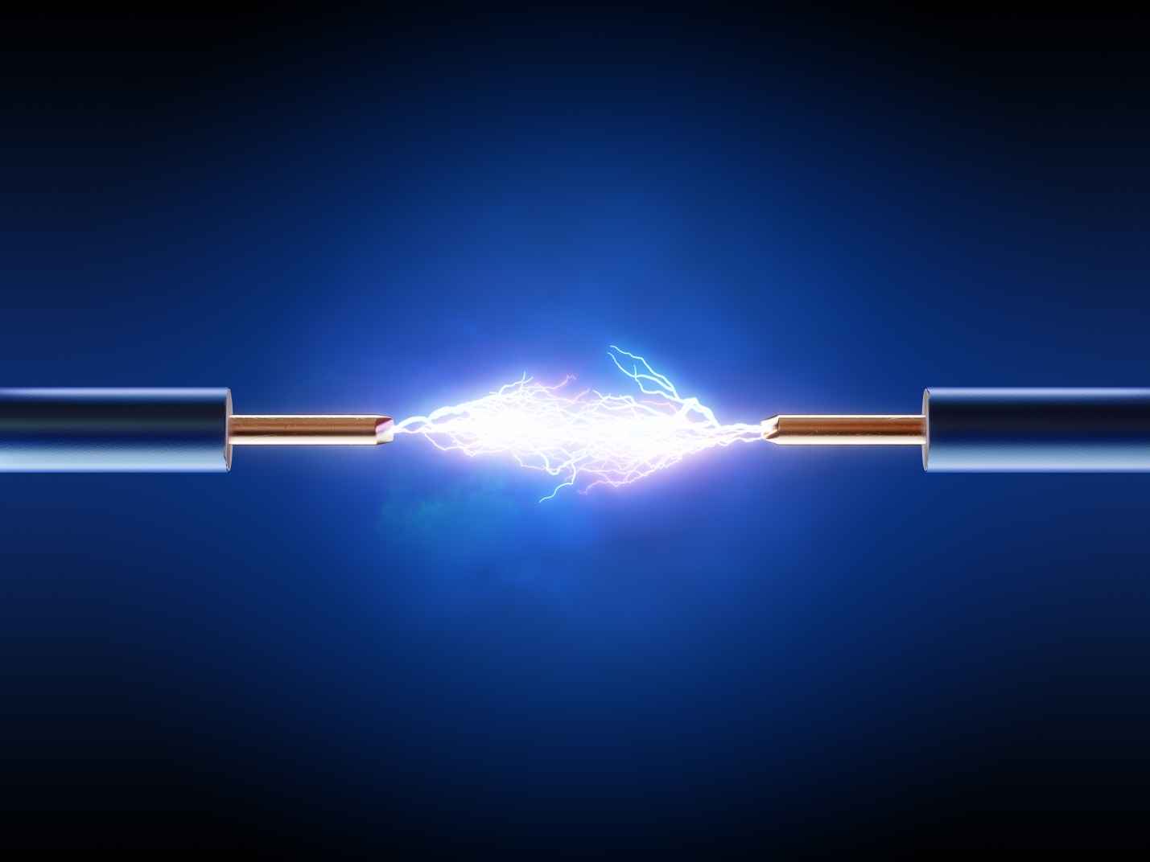Caption:

The PRINTEX kappa 210, PRINTEX kappa 220 and PRINTEX kappa 240 grades increase the dynamic charge acceptance (DCA) of advanced lead-acid batteries by up to 60%. Courtesy of Orion.

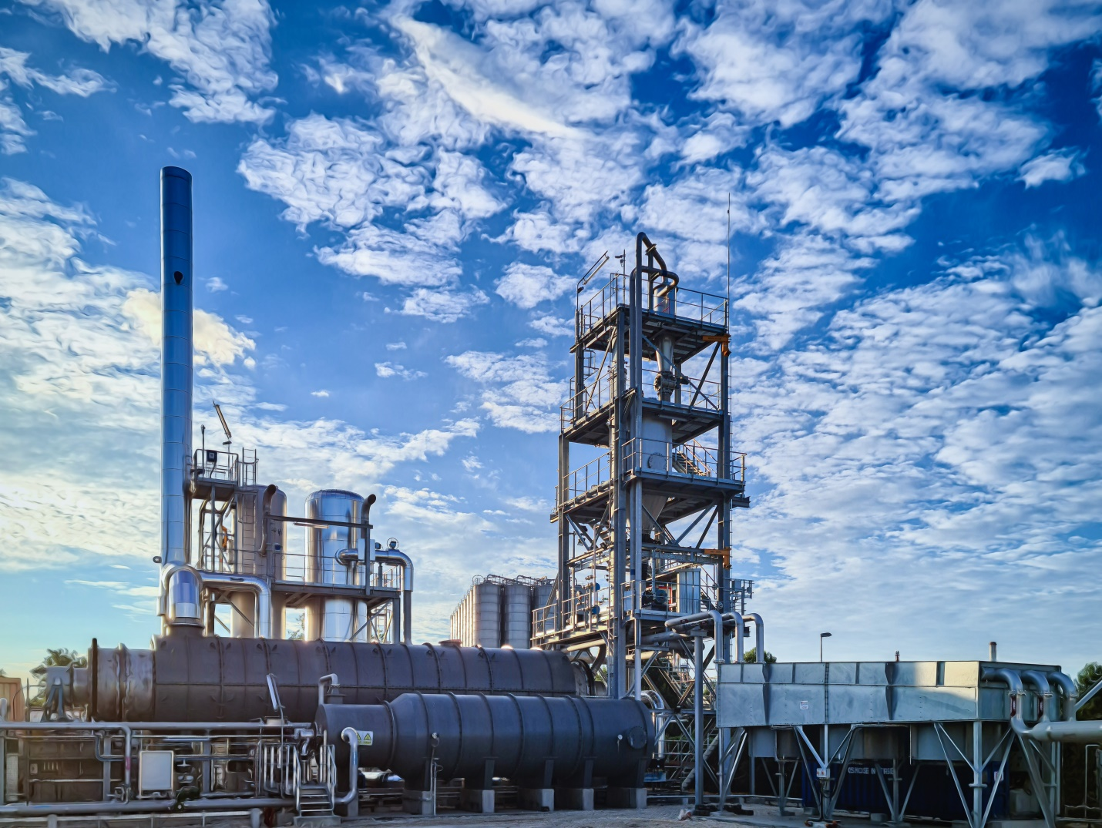

Caption:

This Orion plant in Berre-l’Etang, France, produces acetylene-based conductive additives.