**FOR IMMEDIATE RELEASE: Aug. 15, 2022**

**Orion Highlights Only U.S. Acetylene Conductive Additives Plant at The Battery Show 2022**

HOUSTON – At The Battery Show 2022, global specialty chemicals company [Orion Engineered Carbons](https://www.orioncarbons.com/index_en.php) (NYSE: OEC) is highlighting the benefits of its acetylene-based conductive additives plant, which is in development.

Orion (Booth 1722) announced in May it will build the only plant in the U.S. producing acetylene-based conductive additives – a critical link in the value chain for lithium-ion batteries, high-voltage cables and other products powering the global transition to electrification and renewable energy. The Battery Show takes place Sept. 13-15, 2022 in Novi, Mich.

Planned for LaPorte, Texas, Orion’s new conductive additives plant is expected to start up in the second half of 2024.

“We’re ramping up the supply of conductive additives to match the increasing demand from the EV market for lithium-ion batteries,” said Jennifer S. Stroh, Ph.D., director of specialties sales and marketing Americas. “For the first time, the North American battery market will have domestic availability of shipments and a consistent supply.”

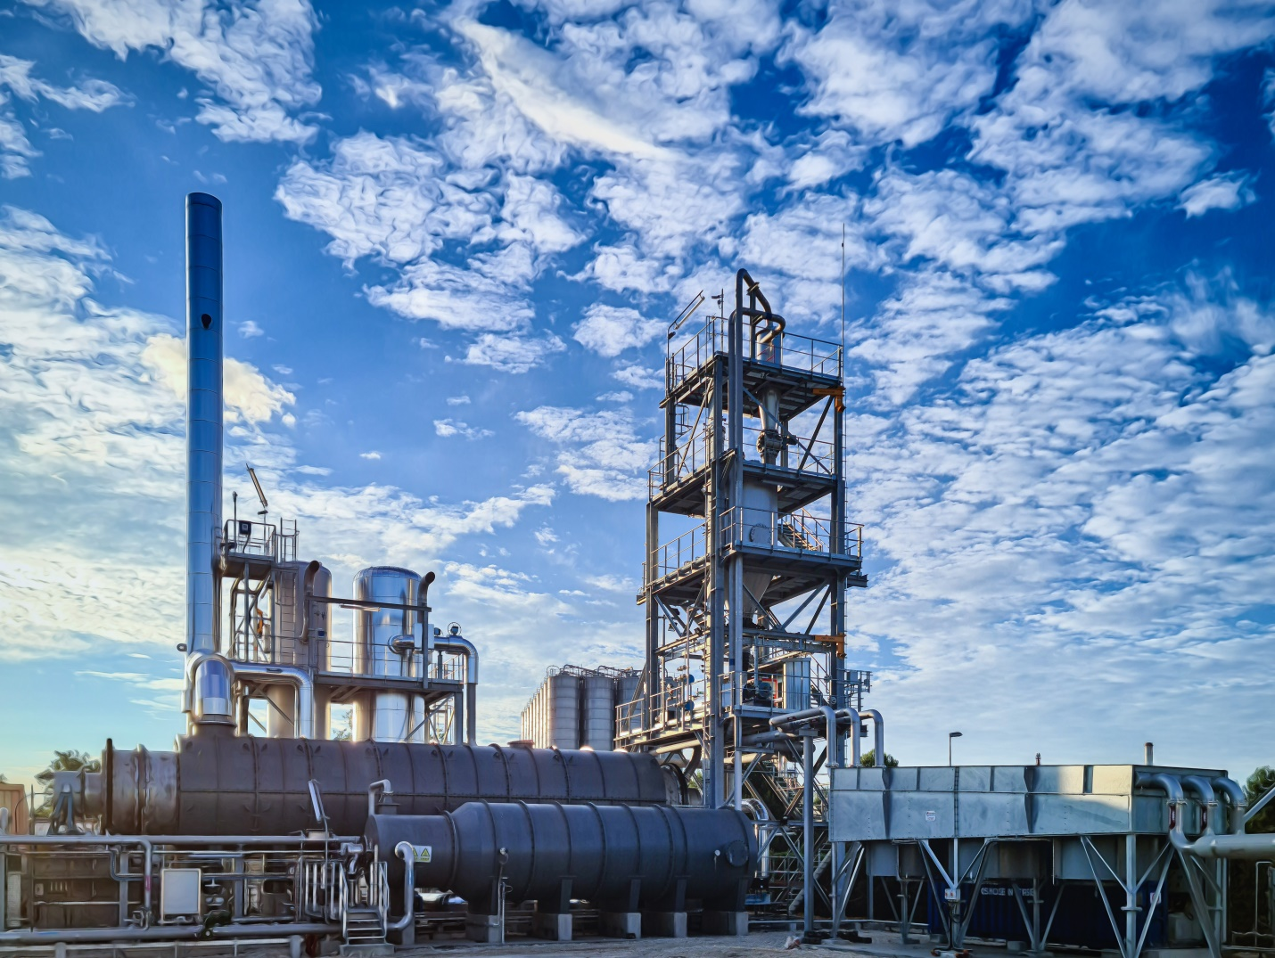

Caption:

This Orion plant in Berre-l’Etang, France, produces acetylene-based conductive additives.

Orion also is showcasing its high-performance acetylene-based conductive additive, PRINTEX® kappa 100, for lithium-ion batteries and its conductive PRINTEX kappa 210, PRINTEX kappa 220 and PRINTEX kappa 240 grades for advanced lead-acid batteries.

**Improving Conductivity in Lithium-ion Batteries**

PRINTEX kappa 100 offers conductive functionalities that improve lithium-ion battery performance. The high-performance acetylene-based conductive additive features exceptional purity and imparts high electrical and thermal conductivity, leading to significantly higher power densities and longer battery life than with other carbon blacks. PRINTEX kappa 100 forms an excellent percolation network across the cathode surface for effective charging and discharging. It is extremely dispersible, for easier formulation, and highly hydrophobic for a better battery lifecycle.

In addition, Orion’s acetylene black production generates a high yield. As a result, PRINTEX kappa 100 has a remarkably low carbon footprint and contributes to the reduction of greenhouse gas emissions.

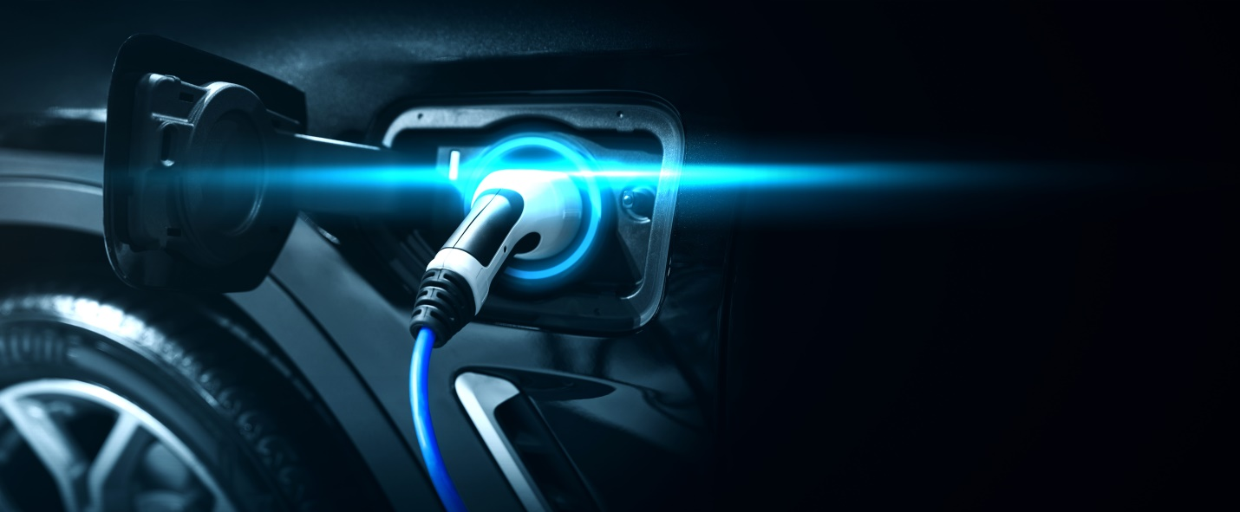

Caption:

Based on acetylene gas, PRINTEX kappa 100 offers conductive functionalities that improve lithium-ion battery performance. Courtesy of Orion.

**Increasing DCA in Advanced Lead-Acid Batteries**

The PRINTEX kappa 210, PRINTEX kappa 220 and PRINTEX kappa 240 grades increase the dynamic charge acceptance (DCA) of advanced lead-acid batteries by up to 60% while maintaining acceptable water loss. They have very low metallic impurities, which results in extended battery cycle life. The modified surface of these PRINTEX kappa grades maintain conductivity and surface area while suppressing the hydrogen evolution reaction, lowering water loss to acceptable levels. As a result, battery manufacturers can use higher loading to achieve higher charge acceptance.

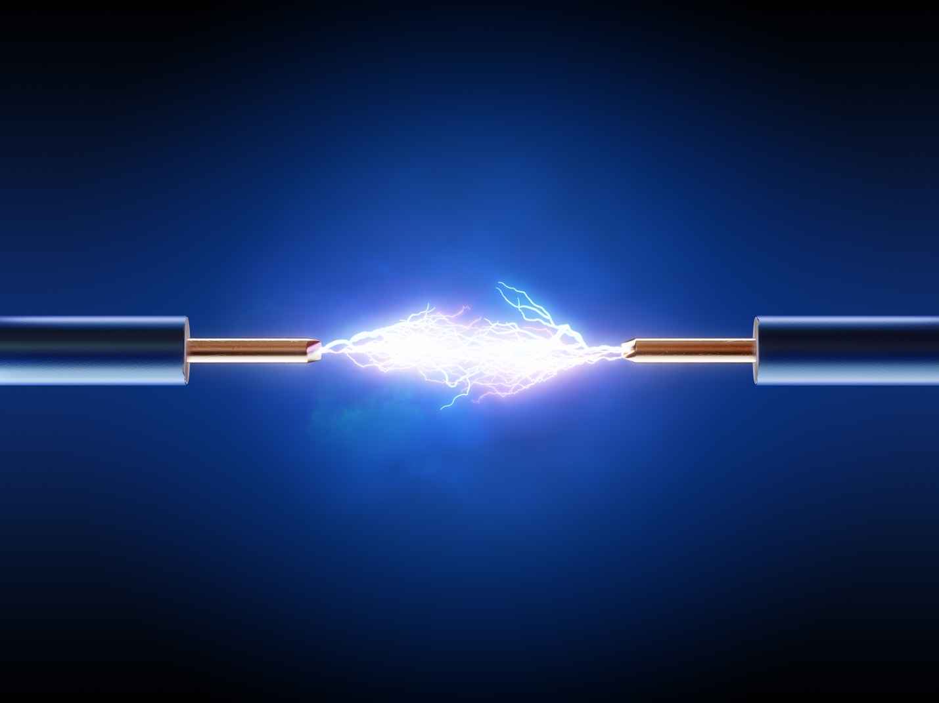

Caption:

The PRINTEX kappa 210, PRINTEX kappa 220 and PRINTEX kappa 240 increase the dynamic charge acceptance (DCA) of advanced lead-acid batteries by up to 60%. Courtesy of Orion.

For more information about OEC’s sustainability performance and initiatives, visit [Orion Engineered Carbons - Sustainability - Sustainability Roadmap (orioncarbons.com)](https://investor.orioncarbons.com/sustainability/Sustainability-Roadmap/default.aspx) .

**About Orion Engineered Carbons**

Orion Engineered Carbons (NYSE: OEC) is a leading global supplier of carbon black, a solid form of carbon produced as powder or pellets. The material is made to customers’ exacting specifications for tires, coatings, ink, batteries, plastics and numerous other specialty, high-performance applications. Carbon black is used to tint, colorize, provide reinforcement, conduct electricity, increase durability, and add UV protection. Orion has innovation centers on three continents and 14 plants worldwide, offering the most diverse variety of production processes in the industry. The company’s corporate lineage goes back more than 160 years to Germany, where it operates the world’s longest-running carbon black plant. Orion is a leading innovator, applying a deep understanding of customers’ needs to deliver sustainable solutions. For more information, please visit [orioncarbons.com](https://www.orioncarbons.com/index_en.php).

**Forward-Looking Statements**

This document contains certain forward-looking statements within the meaning of the U.S. Private Securities Litigation Reform Act of 1995. Forward-looking statements are statements of future expectations that are based on current expectations and assumptions and involve known and unknown risks and uncertainties that could cause actual results, performance or events to differ materially from those expressed or implied in these statements. You should not place undue reliance on forward-looking statements. Each forward-looking statement speaks only as of the date of the particular statement. New risk factors and uncertainties emerge from time to time and it is not possible to predict all risk factors and uncertainties, nor can we assess the extent to which any factor, or combination of factors, may cause actual results to differ materially from those contained in any forward-looking statements. We undertake no obligation to publicly update or revise any forward-looking statement as a result of new information, future events or other information, other than as required by applicable law.

Contact:

William Foreman

Director of Corporate Communications and Government Affairs

Government Affairs

Orion Engineered Carbons

Direct: +1 832-445-3305

Mobile: +1 281-889-7833

[william.foreman@orioncarbons.com](mailto:william.foreman@orioncarbons.com)

###