**FOR IMMEDATE RELEASE, March 17, 2022**

**Orion Showcases “Super Black” Innovations and New Carbon Black Guide at**

**American Coatings Show 2022**

HOUSTON – [Orion Engineered Carbons S.A.](https://www.orioncarbons.com/index_en.php) (NYSE: OEC), a leading global supplier of specialty and high-performance carbon black, is launching its new *“Carbon Black Guide”* and showcasing its ultra-high-jet pigments for automotive coatings at the American Coatings Show (ACS).

In addition, Orion (Booth #1660) is highlighting: NEROX® grades for industrial coatings of all jetness levels and its newest conductive black for coatings applications, PRINTEX® kappa 70. ACS takes place April 5-7 in Indianapolis.

New Carbon Black Guide

Featuring 34 of Orion’s most popular carbon blacks for coatings, the *“Carbon Black Guide”* gives paint formulators a visual sense of the shades they can achieve with different grades. Color chips in the guide show the shades each grade imparts in three coatings types – solid, white blend and alkyd enamel – and details relevant coloristic properties.

“Our new Carbon Black Guide gives formulators an initial visual impression for the color possibilities, making their selection process easier and faster,” said Markus Mahn, director global marketing coatings, Specialty Carbon Black at Orion. “We want to show formulators the many shades of black available, and how our wide range of high-performing carbon blacks can help them create their desired look.”

Mahn said the guide will also be useful to R&D teams as they work to optimize the applications of each grade and develop new ones.

Automotive Coatings

Among the deepest blacks on the market, Orion’s high jet COLOUR BLACK FW 310 and COLOUR BLACK FW 255 grades impart “[ultimate blackness](https://superblackcoatings.com/home/high-jetness-pigments/)” for [automotive coatings](https://www.orioncarbons.com/automotive_coatings).

* COLOUR BLACK FW 310 generates Orion’s highest jetness values with a deep blue undertone. Compatible with water-borne, solvent-borne and high solid applications, it is an excellent choice for automotive OEM basecoats and refinish coatings plus high-end industrial applications.
* COLOUR BLACK FW 255, an after-treated specialty carbon black, offers a balance of coloristic properties and is ideal for a wide range of high-jet applications.

“We continue to strive for the ultimate black and to provide paint formulators with the deepest black in any coating application,” said Jennifer Stroh, Ph.D., director of sales and marketing, Specialties Americas, at Orion.

Industrial Coatings

For [industrial coatings](https://www.orioncarbons.com/industrial_coatings), Orion is highlighting two grades in addition to PRINTEX kappa 70. They enable coatings producers to create varying jetness levels, shades and color-depths.

* NEROX® 1000 is suitable for industrial applications requiring low and medium jetness and low viscosity, even at high concentration.
* NEROX® 605 features high jetness, blue undertone and stable dispersion.

Conductive Coatings

Originally created for use in polymers, PRINTEX kappa 70 conductive black beads:

* Offer better dispersion properties than competitive pigments with the same level of conductivity.
* Are geared for industrial applications, such as epoxy dissipative electrostatic floors, that require low or medium conductivity and anti-static properties.

Orion also is highlighting PRINTEX XE2 B beads, its highest conductive carbon black. PRINTEX XE2 B imparts high conductivity and anti-static properties to primers for automotive parts, and in outer space.

Reflecting Orion’s commitment to sustainability and environmentally responsible coatings, Orion offers all pigments for use in water-borne coating systems.

“While we commit to sustainable growth with minimal environmental impact,” Stroh said, “we also help our customers meet their environmental protection and sustainability targets.”

**About Orion Engineered Carbons**

Orion Engineered Carbons (NYSE: OEC) is a leading global supplier of carbon black, a solid form of carbon produced as powder or pellets. The material is made to customers’ exacting specifications for tires, coatings, ink, batteries, plastics and numerous other specialty, high-performance applications. Carbon black is used to tint, colorize, provide reinforcement, conduct electricity, increase durability, and add UV protection. Orion has innovation centers on three continents and 14 plants worldwide, offering the most diverse variety of production processes in the industry. The company’s corporate lineage goes back more than 160 years to Germany, where it operates the world’s longest-running carbon black plant. Orion is a leading innovator, applying a deep understanding of customers’ needs to deliver sustainable solutions. For more information, please visit [orioncarbons.com](https://www.orioncarbons.com/index_en.php).

**Forward-Looking Statements**

This document contains certain forward-looking statements within the meaning of the U.S. Private Securities Litigation Reform Act of 1995. Forward-looking statements are statements of future expectations that are based on current expectations and assumptions and involve known and unknown risks and uncertainties that could cause actual results, performance or events to differ materially from those expressed or implied in these statements. You should not place undue reliance on forward-looking statements. Each forward-looking statement speaks only as of the date of the particular statement. New risk factors and uncertainties emerge from time to time and it is not possible to predict all risk factors and uncertainties, nor can we assess the extent to which any factor, or combination of factors, may cause actual results to differ materially from those contained in any forward-looking statements. We undertake no obligation to publicly update or revise any forward-looking statement as a result of new information, future events or other information, other than as required by applicable law.

Contact:

William Foreman

Director of Corporate Communications

and Government Affairs

Orion Engineered Carbons

Direct: +1 832-445-3305

Mobile: +1 281-889-7833

[William.Foreman@orioncarbons.com](mailto:William.Foreman@orioncarbons.com)

###

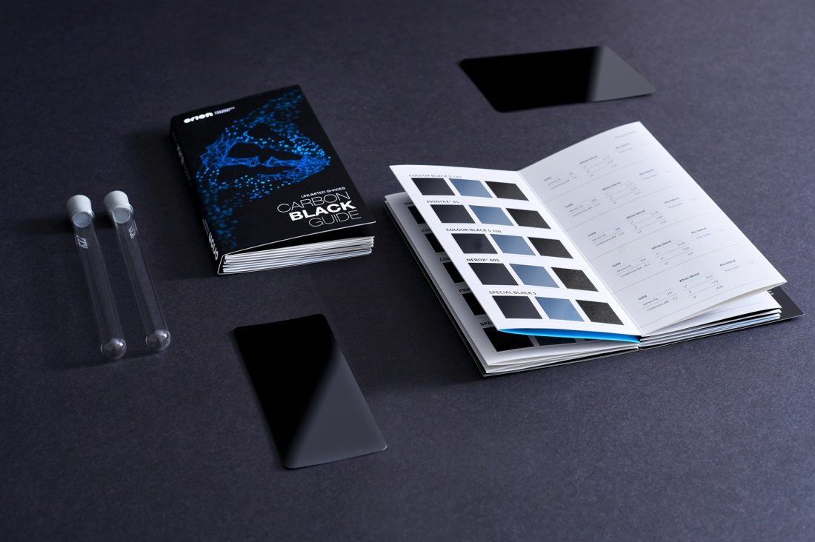

The Orion Engineered Carbons *“Carbon Black Guide”* gives paint formulators a visual sense of the shades they can achieve with different grades.

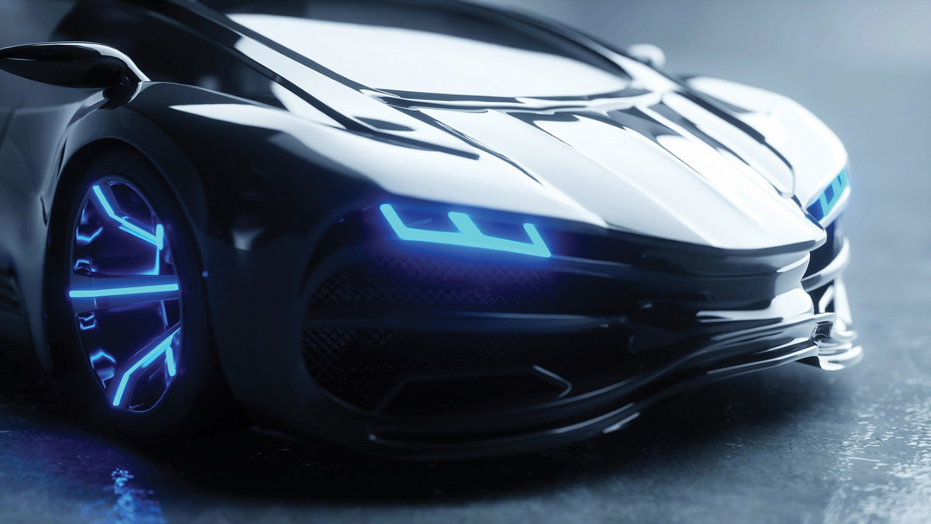

Among the deepest blacks on the market, Orion’s high jet COLOUR BLACK FW 310 and COLOUR BLACK FW 255 grades impart “[ultimate blackness](https://superblackcoatings.com/home/high-jetness-pigments/)” for [automotive coatings](https://www.orioncarbons.com/automotive_coatings).